The task at hand is to figure out where Panasonic stands in each feature (each user rating category) relative to their competitors, and if investing in the feature where users rate them lower than their competitors is the best strategy. If not, what’s the best approach? We also need to create a ranking for features in term of where Panasonic should consider investing first. Assumption is that the cost of improving the feature is same across all features.

Tools Used: **Python (Jupyter Notebook), Excel(Data)**

Files Submitted: **Summary (Word Doc), Jupyter NB (ipynb), Jupyter HTML.**

The Dataset has below features:

*Product Manufacturer*: LG, Panasonic, Sony, Samsung, Philips, Vizio, Sharp, Toshiba

*Screen Size*: 19, 26, 32, 36, 40, 42, 46, 49, 52, 55, 60

*Pixel*: 60, 120, 240, 600

*Motion Rate:* 720, 1080

*Video Quality*

*Sound quality*

*Appearance*

*Number of Features*

*Ease of Set up*

*Life Span*

*Expert Rating*

*Overall Rating*

**Where does Panasonic stand in each feature relative to their competitors?**

Below table gives us the average rating across each feature for Panasonic and all its competitors.

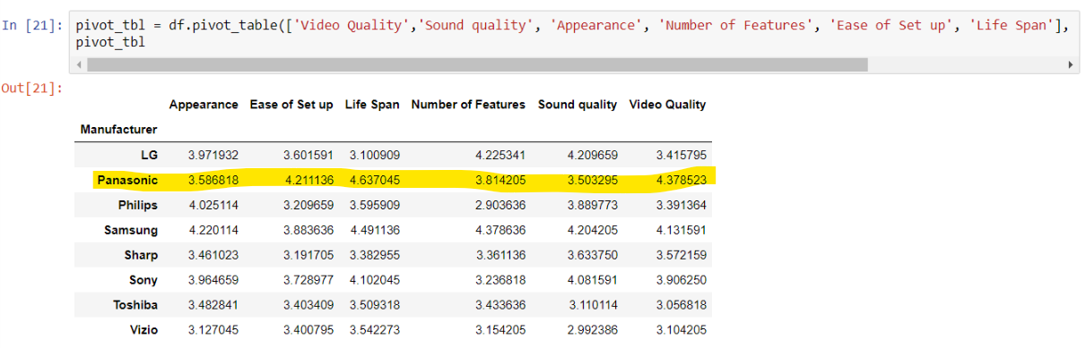

We can see that Panasonic has got favourable average rating in few features, while getting slightly unfavourable and average rating in others.

Below table gives us Panasonic’s rank relative to its competitors across various product features like Video Quality, Sound Quality, Appearance, Life Span etc.

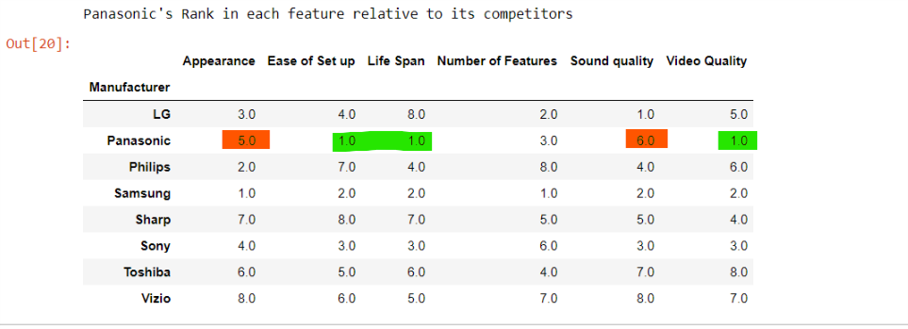

From the table above,

Panasonic is ranked No1 among all brands in:

1. Ease of Set Up
2. Life Span
3. Video Quality

Panasonic ranks 3rd in Number of Features. There’s a scope of improvement in this feature.

Finally, Panasonic ranks #5 in Appearance and #6 in Sound Quality. There’s clearly a need to improve in these features.

Having said that, we need to check the significance of each feature and find out which of them are most significant towards the number of units sold on yearly basis.

Regression analysis helps in explaining the significance of each of the features. This will help Panasonic decide the order in which they must prioritize to improve the features to increase sales.

Ordinary Least Square(OLS) regression was performed on the features with the ‘Yearly Units sold in US’ as the Goal Variable. We consider data from all manufacturers to gauge the overall impact of these features on yearly units sold across the industry.

Below is the regression summary.

|  |  |  |  |  |  |  |  |  |  |  |  |  |  |  |  |  |  |  |  |  |  |  |  |  |  |  |  |  |  |  |  |  |  |  |  |  |  |  |  |  |  |  |  |  |  |  |  |  |  |  |  |  |  |  |  |  |  |  |  |  |  |  |  |  |  |  |  |  |  |  |  |  |  |  |  |  |  |  |  |  |  |  |  |  |  |  |  |  |  |  |  |  |  |  |  |  |  |  |  |  |  |  |  |  |  |  |  |  |  |  |  |  |  |  |  |  |  |  |  |  |  |  |  |  |  |  |  |  |  |  |  |  |  |  |  |  |  |  |  |  |  |  |  |  |  |  |  |  |  |  |  |  |  |  |  |  |  |  |  |  |  |  |  |  |  |  |  |  |  |  |  |  |  |  |  |  |  |  |  |  |  |  |  |  |  |  |  |  |  |  |  |  |  |  |  |  |  |  |  |  |  |  |  |  |  |  |  |  |  |  |  |  |  |  |  |  |  |  |  |  |  |  |  |  |  |  |  |  |  |  |  |
| --- | --- | --- | --- | --- | --- | --- | --- | --- | --- | --- | --- | --- | --- | --- | --- | --- | --- | --- | --- | --- | --- | --- | --- | --- | --- | --- | --- | --- | --- | --- | --- | --- | --- | --- | --- | --- | --- | --- | --- | --- | --- | --- | --- | --- | --- | --- | --- | --- | --- | --- | --- | --- | --- | --- | --- | --- | --- | --- | --- | --- | --- | --- | --- | --- | --- | --- | --- | --- | --- | --- | --- | --- | --- | --- | --- | --- | --- | --- | --- | --- | --- | --- | --- | --- | --- | --- | --- | --- | --- | --- | --- | --- | --- | --- | --- | --- | --- | --- | --- | --- | --- | --- | --- | --- | --- | --- | --- | --- | --- | --- | --- | --- | --- | --- | --- | --- | --- | --- | --- | --- | --- | --- | --- | --- | --- | --- | --- | --- | --- | --- | --- | --- | --- | --- | --- | --- | --- | --- | --- | --- | --- | --- | --- | --- | --- | --- | --- | --- | --- | --- | --- | --- | --- | --- | --- | --- | --- | --- | --- | --- | --- | --- | --- | --- | --- | --- | --- | --- | --- | --- | --- | --- | --- | --- | --- | --- | --- | --- | --- | --- | --- | --- | --- | --- | --- | --- | --- | --- | --- | --- | --- | --- | --- | --- | --- | --- | --- | --- | --- | --- | --- | --- | --- | --- | --- | --- | --- | --- | --- | --- | --- | --- | --- | --- | --- | --- | --- | --- | --- | --- | --- | --- | --- | --- | --- | --- | --- | --- | --- | --- | --- |
| |  |  |  |  | | --- | --- | --- | --- | | OLS Regression Results | | | | | **Dep. Variable:** | Yearly units sold in US | **R-squared:** | 1.000 | | **Model:** | OLS | **Adj. R-squared:** | 1.000 | | **Method:** | Least Squares | **F-statistic:** | 3.147e+05 | | **Date:** | Thu, 01 Mar 2018 | **Prob (F-statistic):** | 0.00 | | **Time:** | 21:49:09 | **Log-Likelihood:** | -3728.3 | | **No. Observations:** | 704 | **AIC:** | 7505. | | **Df Residuals:** | 680 | **BIC:** | 7614. | | **Df Model:** | 23 |  |  | | **Covariance Type:** | nonrobust |  |  |  |  |  |  |  |  |  |  | | --- | --- | --- | --- | --- | --- | --- | |  | **coef** | **std err** | **t** | **P>|t|** | **[0.025** | **0.975]** | | **Overall Rating** | 129.8666 | 6.152 | 21.108 | 0.000 | 117.787 | 141.947 | | **Video Quality** | 590.4260 | 6.633 | 89.012 | 0.000 | 577.402 | 603.450 | | **Sound quality** | 59.2385 | 5.459 | 10.851 | 0.000 | 48.519 | 69.957 | | **Appearance** | 212.5589 | 5.652 | 37.610 | 0.000 | 201.462 | 223.656 | | **Number of Features** | 435.9875 | 3.639 | 119.804 | 0.000 | 428.842 | 443.133 | | **Ease of Set up** | 312.6551 | 5.515 | 56.691 | 0.000 | 301.827 | 323.484 | | **Life Span** | 116.5273 | 5.731 | 20.333 | 0.000 | 105.275 | 127.780 | | **Expert Overall Rating** | 28.4796 | 6.347 | 4.487 | 0.000 | 16.018 | 40.941 | | **size=26"** | 1007.4753 | 9.097 | 110.743 | 0.000 | 989.613 | 1025.338 | | **size=32"** | 2002.1033 | 10.966 | 182.570 | 0.000 | 1980.572 | 2023.635 | | **size=36"** | 6016.6029 | 13.026 | 461.906 | 0.000 | 5991.028 | 6042.178 | | **size=40"** | 1012.3222 | 16.007 | 63.243 | 0.000 | 980.894 | 1043.751 | | **size=42"** | 8016.8643 | 19.026 | 421.357 | 0.000 | 7979.507 | 8054.222 | | **size=46"** | 1.252e+04 | 22.670 | 552.467 | 0.000 | 1.25e+04 | 1.26e+04 | | **size=49"** | -480.4490 | 25.626 | -18.749 | 0.000 | -530.764 | -430.133 | | **size=52"** | -1029.1550 | 29.289 | -35.138 | 0.000 | -1086.663 | -971.647 | | **size=55"** | -1892.5467 | 32.507 | -58.219 | 0.000 | -1956.374 | -1828.720 | | **size=60"** | -4978.4248 | 36.141 | -137.752 | 0.000 | -5049.385 | -4907.464 | | **motionrate=120** | 100.6476 | 5.878 | 17.122 | 0.000 | 89.106 | 112.189 | | **motionrate=240** | 203.6658 | 7.760 | 26.247 | 0.000 | 188.430 | 218.901 | | **motionrate=600** | 303.8723 | 9.921 | 30.631 | 0.000 | 284.394 | 323.351 | | **Pixel=1080** | 355.9644 | 5.548 | 64.159 | 0.000 | 345.071 | 366.858 | | **Selling Price** | -3.0492 | 0.058 | -52.365 | 0.000 | -3.164 | -2.935 | | **Intercept** | 1.048e+04 | 24.732 | 423.747 | 0.000 | 1.04e+04 | 1.05e+04 |  |  |  |  |  | | --- | --- | --- | --- | | **Omnibus:** | 0.493 | **Durbin-Watson:** | 1.970 | | **Prob(Omnibus):** | 0.781 | **Jarque-Bera (JB):** | 0.383 | | **Skew:** | -0.048 | **Prob(JB):** | 0.826 | | **Kurtosis:** | 3.063 | **Cond. No.** | 3.45e+04 | |
|  |  |  |  |

As we can see from above regression summary, the model has very high R-Square. In fact, R-square converges to 1. So, we can assert that the model is able to capture almost all the information and explain all the variance present in the dataset.

Looking at co-efficient (and t-value/P-value) of the product features, we can see that **Video Quality, Number of Features, Ease of Set-up and Appearance** are the most significant contributors towards the overall yearly sales.

Looking at the above regression result, we can prioritize in the below order:

|  |  |  |  |
| --- | --- | --- | --- |
| **Feature** | **Existing Market Rank** | **Co-efficient** | **Prioritizing Investing Order** |
| Video Quality | 1 | 590.426 | - |
| **Number of Features** | 3 | 435.9875 | **1** |
| Ease of Setup | 1 | 312.6551 | - |
| **Appearance** | 5 | 212.5589 | **2** |
| Life Span | 1 | 116.5273 | - |
| **Sound Quality** | 6 | 59.2385 | **3** |

Video Quality, Ease of Setup and Life Span are the features in which Panasonic already ranks #1 and is the industry leader. Therefore, we need to invest in other features.

Based on the co-efficient, we choose to go ahead with below order:

1. Number of Features
2. Appearance
3. Sound Quality

For every unit increase in Number of features i.e. every unit increase in average rating for Number of Features, Panasonic is likely to sell about 436 more units every year in US.

Similarly, for every unit increase in average rating for Appearance and Sound Quality, Panasonic is likely to sell about 212 and 59 more units respectively, every year in US.

**Adding Price Difference:**

We add a new independent variable ‘Price Diff’ to account for the effect of competition among manufacturers.

Price difference is the difference between the focal product's price and the average price for that segment, where segment is defined by the combination of product aspects (Screen Size, Pixel, and Motion Rate).

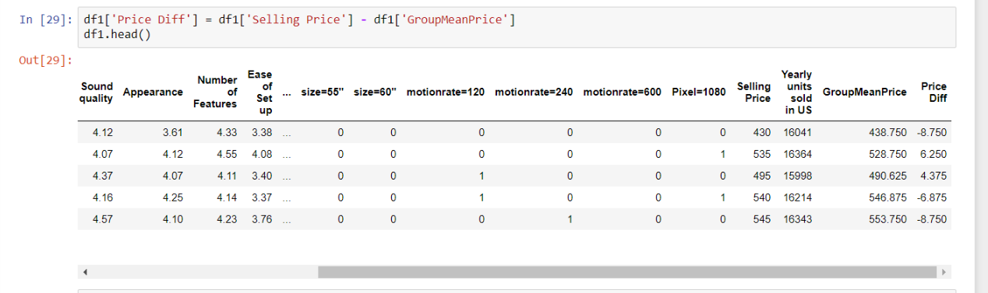

Next, we build a OLS Regression with 'Yearly Units sold in US' as the goal variable and all other variables (including the newly created 'Price Diff') as the independent variables.

Below is the summary from OLS regression.

|  |  |  |  |
| --- | --- | --- | --- |
| OLS Regression Results | | | |
| **Dep. Variable:** | Yearly units sold in US | **R-squared:** | 1.000 |
| **Model:** | OLS | **Adj. R-squared:** | 1.000 |
| **Method:** | Least Squares | **F-statistic:** | 2.012e+05 |
| **Date:** | Fri, 02 Mar 2018 | **Prob (F-statistic):** | 0.00 |
| **Time:** | 02:10:18 | **Log-Likelihood:** | -3885.7 |
| **No. Observations:** | 704 | **AIC:** | 7819. |
| **Df Residuals:** | 680 | **BIC:** | 7929. |
| **Df Model:** | 23 |  |  |
| **Covariance Type:** | nonrobust |  |  |

|  |  |  |  |  |  |  |
| --- | --- | --- | --- | --- | --- | --- |
|  | **coef** | **std err** | **t** | **P>|t|** | **[0.025** | **0.975]** |
| **Appearance** | 214.7484 | 7.096 | 30.261 | 0.000 | 200.815 | 228.682 |
| **Ease of Set up** | 311.9369 | 6.899 | 45.218 | 0.000 | 298.392 | 325.482 |
| **Expert Overall Rating** | 20.4334 | 8.024 | 2.547 | 0.011 | 4.680 | 36.187 |
| **Life Span** | 116.5499 | 7.186 | 16.219 | 0.000 | 102.440 | 130.659 |
| **Number of Features** | 435.4757 | 4.553 | 95.654 | 0.000 | 426.537 | 444.414 |
| **Overall Rating** | 126.6985 | 7.720 | 16.412 | 0.000 | 111.541 | 141.856 |
| **Pixel=1080** | 136.5450 | 4.639 | 29.432 | 0.000 | 127.436 | 145.654 |
| **Price Diff** | -2.9745 | 0.077 | -38.835 | 0.000 | -3.125 | -2.824 |
| **Sound quality** | 55.1150 | 6.850 | 8.046 | 0.000 | 41.666 | 68.564 |
| **Video Quality** | 592.0965 | 8.306 | 71.289 | 0.000 | 575.789 | 608.404 |
| **motionrate=120** | -42.8813 | 6.591 | -6.507 | 0.000 | -55.822 | -29.941 |
| **motionrate=240** | -98.6170 | 6.595 | -14.954 | 0.000 | -111.566 | -85.669 |
| **motionrate=600** | -141.8566 | 6.584 | -21.547 | 0.000 | -154.783 | -128.930 |
| **size=26"** | 835.0687 | 10.917 | 76.492 | 0.000 | 813.634 | 856.504 |
| **size=32"** | 1649.0856 | 10.898 | 151.322 | 0.000 | 1627.688 | 1670.483 |
| **size=36"** | 5491.9313 | 10.891 | 504.255 | 0.000 | 5470.547 | 5513.316 |
| **size=40"** | 296.6223 | 10.906 | 27.197 | 0.000 | 275.208 | 318.037 |
| **size=42"** | 7120.4260 | 10.882 | 654.361 | 0.000 | 7099.061 | 7141.791 |
| **size=46"** | 1.142e+04 | 10.888 | 1048.905 | 0.000 | 1.14e+04 | 1.14e+04 |
| **size=49"** | -1757.7627 | 10.880 | -161.564 | 0.000 | -1779.124 | -1736.401 |
| **size=52"** | -2498.3246 | 10.885 | -229.512 | 0.000 | -2519.698 | -2476.952 |
| **size=55"** | -3534.3877 | 10.895 | -324.392 | 0.000 | -3555.780 | -3512.995 |
| **size=60"** | -6815.7772 | 10.912 | -624.634 | 0.000 | -6837.202 | -6794.353 |
| **Intercept** | 9168.4823 | 55.978 | 163.787 | 0.000 | 9058.572 | 9278.393 |

|  |  |  |  |
| --- | --- | --- | --- |
| **Omnibus:** | 5.642 | **Durbin-Watson:** | 2.018 |
| **Prob(Omnibus):** | 0.060 | **Jarque-Bera (JB):** | 5.425 |
| **Skew:** | -0.176 | **Prob(JB):** | 0.0664 |
| **Kurtosis:** | 2.754 | **Cond. No.** | 1.83e+03 |

We can see that the co-efficient of all the features have changed slightly. However, the order remains the same.

Therefore, there's no impact on the order in which Panasonic should invest in the features.

However, the newly created independent variable 'Price Diff' is significant in the model and provides some interesting information. Co-efficient for this variable is negative, which indicates that for every unit increase in the price difference, the company sells about 3 units less on yearly basis in US.

Therefore, Panasonic can match their selling price with the average industry price (for the segment based on product aspects).

The company can go even further and lower their prices to positively impact their sales.

For instance, in the segment Screen Size = 19, Pixel = 120 and Motion Rate = 1080, Panasonic sells its products at $570. However, the industry average for this segment is $546.875, which is about $23 less than that of Panasonic’s price. In this case, Panasonic sells about 8 units less. Therefore, by reducing the prices to industry average levels, Panasonic can increase its yearly sales in US.

Panasonic needs to conduct further study to find the optimum selling price levels and come up with a strategy to reduce prices on some key product segments. The company also needs to prioritize investment in the following order: Number of Features > Appearance > Sound Quality.

**Priyaranjan Pattnayak**

**MSIS class of 2018**